Maritime Decarbonisation – Research & Development
Caribbean and Global Perspectives
The IMO CARES Foundation Project in collaboration with MTCC Caribbean hosted the first virtual workshop on the IMO CARES Project. The workshop aimed to facilitate regional consultations on the IMO CARES concept, provide perspectives on maritime decarbonisation R&D and identify challenges and solutions related to maritime decarbonisation technology within the region. The outcomes of the workshop included:
- Facilitating regional consultations on the IMO CARES concept;
- Providing perspectives on R&D related to maritime decarbonization from Decarbonization Centres;
- Identifying the challenges related to decarbonization technology within the Caribbean region; and
- Identifying solutions to these challenges and discussing the way forward.
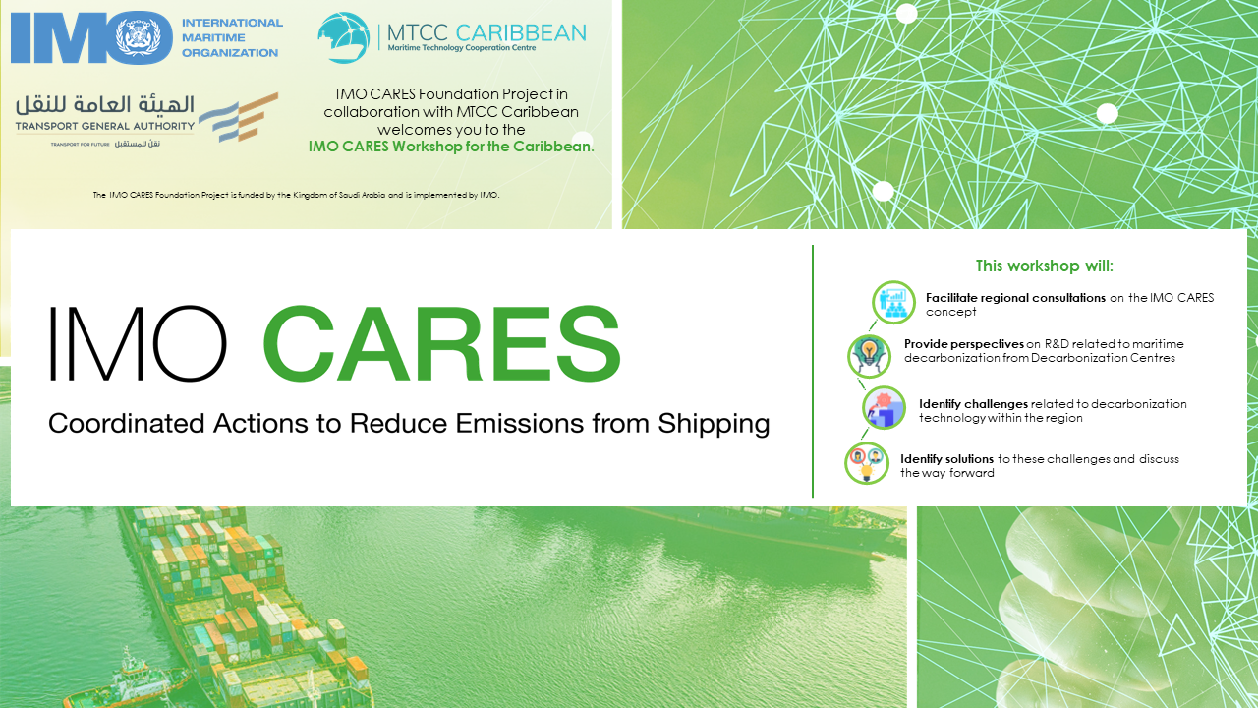
Hosted on June 22nd, 2022, via the Zoom platform, the workshop yielded over 110 registrants, from 30 countries, from regions such as the Caribbean, Latin America, Europe, North America, Africa, Middle East, Asia and the Pacific. The participants comprised a mixture of maritime administrations, port authorities, ship owner/operators, fuel/energy providers, NGOs, technology providers, academia, research and innovation centres, policy makers and other key industry stakeholders. Click here to watch Workshop Recording

Keynote Addresses
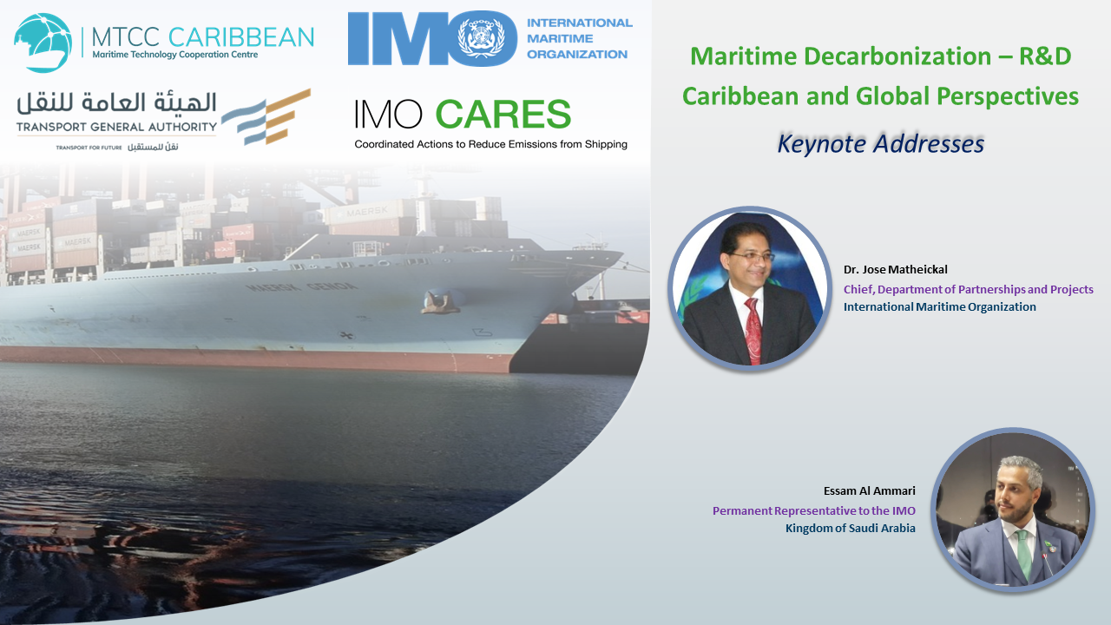
Dr. Jose Matheickal, Chief, Department of Partnerships and Projects, IMO, opened the proceedings by welcoming all presenters, panellist and participants. Dr. Matheickal thanked the Kingdom of Saudi Arabia for funding the IMO CARES Foundation Project. Dr. Matheickal also thanked MTCC Caribbean and The University of Trinidad and Tobago (UTT) for its tremendous work, continuous cooperation with IMO and the work done to support the wider Caribbean Region.
Engineer Essam Al Ammari, Permanent Representative to the IMO for Saudi Arabia, also expressed his gratitude towards IMO, MTCC Caribbean and UTT for facilitating the workshop and called on the region to support the IMO CARES Project. Engineer Al Ammari commended the valuable work undertaken by MTCC Caribbean in developing maritime technology innovation possibilities and noted that workshops and networks such as the IMO CARES project is fundamental and foundational towards promoting technology transfer, maritime decarbonisation and Agenda 2030.

IMO Cares – An introduction
The presentations began with an introduction to the IMO CARES Foundation Project, delivered by Mr. Anton Rhodes, Project Manager, IMO. Mr. Rhodes indicated that the initial objective of the project is to undertake all the preparatory activities to develop and design the long-term CARES programme, which includes, developing the CARES framework, stakeholder engagement, promotion and visibility and feasibility of MTCCs regional expansion. On outlining the key milestones of the project, Mr. Rhodes illustrated that the focus will be on delivering technical workshops, completing a roadmap document for establishing new MTCCs, engagement at the IMO Innovation Forum and the FinSMART Roundtable, and completion of the CARES framework document.
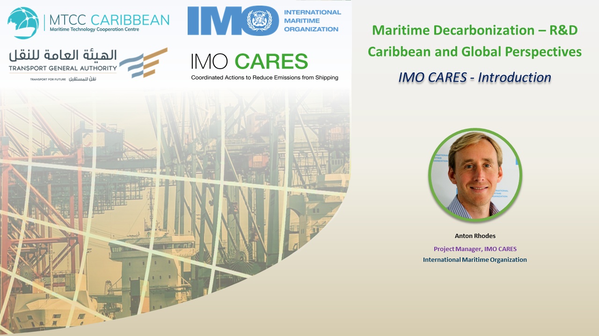
In his presentation, Mr. Rhodes also discussed the IMO CARES concept, which focuses on identifying and overcoming the challenges related to global technology transfer and diffusion, and a lack of globally demonstrated technologies and alternative fuels. He noted that IMO CARES will look for solutions to these challenges by creating a globally coordinated programme to catalyse innovation, technology cooperation and demonstrations through field activities, and bring private sector and financing institutions to support this effort. In illustrating the IMO CARES work packages, Mr. Rhodes indicated that it is envisaged that MTCCs will provide outreach and coordination to run events, identify innovation challenges and support feasibility studies and pilot demonstration in their respective regions. Concluding his presentation, Mr. Rhodes emphasised that as the maritime sector is on a path to decarbonisation, there are technology and investment gaps between the global north and global south. He noted that there is a need for huge R&D and infrastructure investments to meet GHG targets and the biggest challenge in the short term is to ensure that no country or region is left behind in this transition to decarbonisation.

Overview of R&D related to Maritime Decarbonisation – Global Perspectives
Session one of the workshop was moderated by Mrs. Vivian Rambarath-Parasram, Director and Head, MTCC Caribbean and included four presentations that each provided an overview of their global perspective of R&D related to maritime decarbonisation.
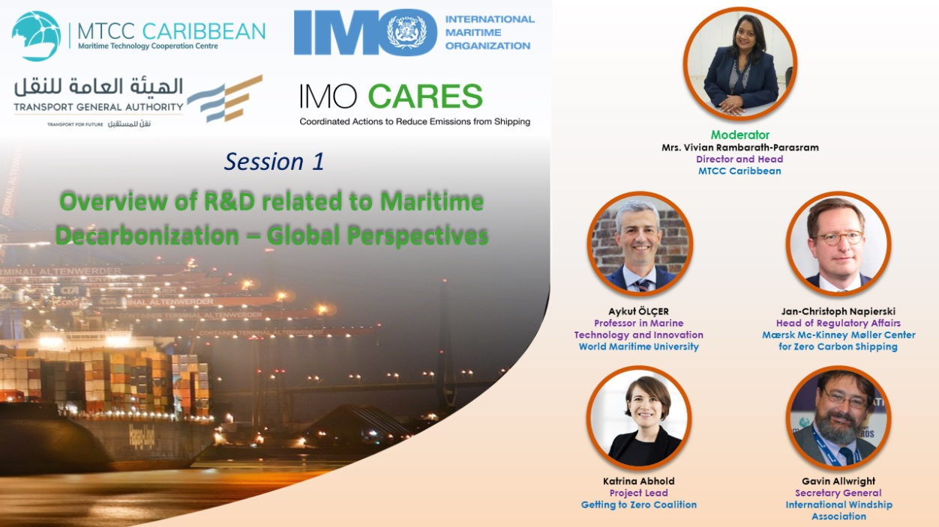
Professor Dr. Aykut I. Ölçer, Director of Research, Nippon Foundation Professorial Chair in Marine Technology and Innovation, Head Maritime Energy Management (MEM) Specialization, WMU, delivered the first presentation of session one of the workshop. Professor Ölçer illustrated new technologies for greener shipping and discussed the IMO’s ambitious targets and emissions gap. However, he noted that there is no single existing “silver bullet” technology, which, therefore mean that industry requires further innovation and relevant research and development to guide cost and non-cost related barriers. Professor Ölçer also presented demonstration projects such as HYSEAS III, SHIPFC, FASTWATER, SEATECH2020, E-SHYIPS, HYSHIP, EMERGE, GATERS, NAUTILUS, AIRCOAT, MAGPIE, PIONEERS, HYMETHSHIP, CHEK and ENGIMMONIA. He then proceeded to illustrate these projects by energy source, value chain and by regions. On concluding, Professor Ölçer noted that there is a gap and a need for holistic and transdisciplinary centric research, alternative fuels, electrification and renewable energy, life-cycle cost/environmental analysis of measures, economic measures, life cycle perspectives within energy and maritime supply chain and the trade-off between smarter, safer and greener shipping.
The second presentation of session one was delivered by Mr. Jan-Christoph Napierski, Head of Regulatory Affairs, Mærsk Mc-Kinney Møller Center for Zero Carbon Shipping. Mr Napierski illustrated that the industry is heading for an increase in maritime GHG emissions despite current industry-wide efforts and called on the need to share the zero-carbon vision and commitment to collaborative climate action. In addressing the issue, Mr. Napierski indicated that accelerated progress is needed in four areas during the next decade to meet the 2050 target, these are, energy efficiency support across the value chain, alternative fuels available at scale, a level playing field with global regulation and support to first movers. He noted that ship efficiency technology is available, but not fully utilised. He stressed that while the cost and scalability of future decarbonised fuel is highly uncertain, but without a price on carbon emission fossil fuels will continue to be cheaper. Mr. Napierski concluded by identifying green corridors to kickstart the transition and illustrating ongoing works in various regions that are seeking to activate the full value chain, which includes fuel production, port logistics and bunkers and vessel types and technologies.
Following Mr. Napierski, Ms. Katrina Abhold, Project Lead, Global Opportunities at Global Maritime Forum presented on the ongoing decarbonisation works of the Getting to Zero Coalition by illustrating the opportunities in emerging economies of South Africa, Mexico and Indonesia. Her presentation identified the challenges and opportunity similarities across the countries, namely with respect to technology adoption, challenges with grid connectivity, public private collaboration, aggregating demand, scaling renewable infrastructure and government signals. Ms. Abhold also illustrated and discussed the regional opportunities for decarbonising maritime transport in Latin America, including its renewable energy potential.
The final presentation of session one was delivered by Mr. Gavin Allwright, Secretary General, International Windship Association (IWSA). His presentation included an update of the IWSA’s network and focused on the developments of wind power globally. While Mr. Allwright presented on some key consideration and concepts in assessing wind power technology and ongoing R&D projects, he noted that what may work for Europe will not necessarily work for the Caribbean. Mr. Allwright concluded by making a call to policy decision makers to go beyond the current narrow fuel-centric approach to ensure a level playing field and noted that immediate action is needed for a just transition, especially with respect to sustained support and funding for LDCs and SIDS who are most impacted by ocean and climate degradation.
Following the presentations, the session ended with questions and answer segment. First question was asked on the developments of nuclear power as alternative source of energy and why was it not mentioned among other solutions. Professor Ölçer responded that although it is a promising alternative, but the challenge is the perception of the technology. He indicated that much research is being conducted on uranium, but it is not a mature technology, although it has developed for the past 50 to 60 years when it comes to the safety aspect. Professor Ölçer also added that it is a zero-emission alternative, but it is not renewable, as 80 kilogram of uranium can propel a ship for 25years with no carbon.
The second key question was directed at Mr. Napierski, on where he would like to see the next green corridor. Mr. Napierski, responded that there are number of regions that can establish a green corridor, but you have to look at the energy production and the energy potential. He pointed at some recent developments in South America, North America, Asia and Africa, with new candidates in the pipelines. However, it will depend on the technological and economical parameters and the ability of the business partners to engage and contribute resources, data and analysis. There was a follow up question on any R&D specific to SIDS being championed by Mærsk Mc-Kinney Møller Center for Zero Carbon Shipping. Mr. Napierski highlighted that their ongoing works with Palau and that there are great opportunities for SIDS to access finances.
The next question was directed to Mr. Allwright, on how the IWSA is planning to bring the global partnerships and Windships to the Caribbean. Mr. Allwright indicated that the association has projects developing in Costa Rica and a number of hub developments looking at developing smaller vessels. However, he cited that one of the issues is taking technology from Europe and trying to fit them into an operation that it is not compatible with, which can result in unintended consequences. He called for the just transition approach and for R&D to be originated from the region. Dr. Matheickal then questioned if any of the presenters had any experience with the regional development banks coming forward providing the financing to develop the new technology that has risk involved. Mr Allwright provided feedback, indicating that in the past there were various banks getting involved in pilot projects, but there was never a pathway to move it from R&D to into full scale implementation. However, Mr. Allwright also added that a change is being seen where banks are becoming more interested when you have the financial sector and commercial sector collaborating.
The final question of session one was directed to Mr. Rhodes, and requested his insights on the IMO CARES project fitting into existing IMO technical cooperation projects to ensure efforts are not duplicated. Mr Rhodes responded by emphasising that IMO GHG technical cooperation work is focused on different types of interventions (awareness raising, human capacity building and legal, policy and institutional capacity building). He added that IMO CARES is focusing significantly on technology and infrastructure capacity building, and within that space there are other initiatives and element, which IMO CARES is envisioned to coordinate the separate initiatives, with a clear mandate on in-region application of new technologies, by using the network of stakeholders available at the IMO. Mr. Rhodes also added that one intention is to place the MTCCs at the heart of the initiative in terms of outreach to the different regions.
Overview of Decarbonisation Technology Challenges from the Region
Session two of the workshop was moderated by Captain Sukhjit Singh, Head of School (Maritime Science) University of Gibraltar and Technical Head, MTCC Caribbean, and included four presentations which provided an overview of the decarbonisation opportunities and challenges from different stakeholder perspectives within the Caribbean region.
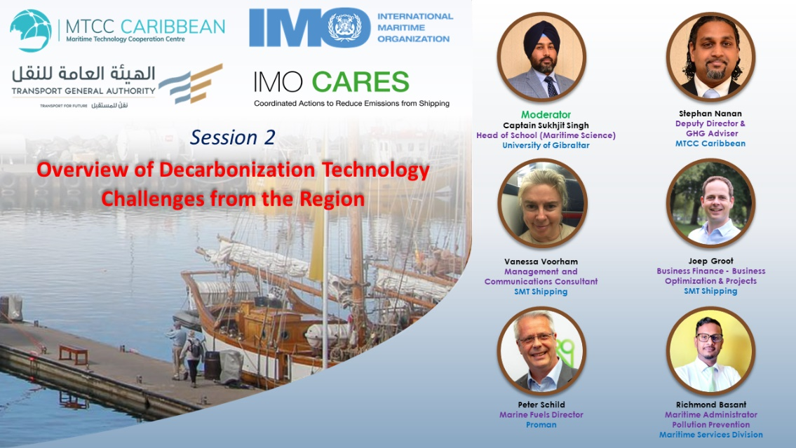
Mr. Stephan Nanan, Deputy Director and GHG Advisor, MTCC Caribbean, presented the first presentation of session two. His presentation provided insights into some preliminary results of MTCC Caribbean’s most recent work, which involves the implementation of a Port GHG emission inventory at an industrial port in the region. Mr. Nanan, in his presentation, underscored the importance of implementing the inventory, discussed the methodology adopted from the GloMEEP port emission toolkit and highlighted the challenges in implementation. On concluding the presentation, Mr. Nanan recommended that in the coming years all ports in the region will carry out a ports emissions inventory to determine their baseline emissions data and help inform emissions reduction strategies as the region continue working towards meeting the industry reduction targets from all elements of the industry. However, he emphasised that this will require more transparency and data sharing, particularly with respect to acquiring fuel consumption figures and particulars of vessels calling to the ports.
The second presentation of session two was delivered jointly by Ms. Vanessa Voorham, Management and Communication Consultant and Mr. Joep Groot, Business Finance – Business Optimization and Project, SMT Shipping. The presentation began with Ms. Voorham providing an overview of SMT Shipping, with particular reference to its operations in the Caribbean region, of which in 2021 saw over 330 port calls and over 7.05 million tons of cargo transported. Mr Groot then followed with SMT’s sustainable shipping progress and its Towards Zero initiative. Mr. Groot also illustrated their steps towards carbon reduction in their existing fleet, however noted that savings seen by larger companies that implement consumption and emission optimisation are not the same as smaller shipping companies, who experience generally less and, in some cases, margins show zero-business case.
Following SMT’s presentation, Proman’s Director of Marine Fuels, Mr. Peter Schild highlighted the role of Proman’s perspectives in providing and enabling methanol as an alternative marine fuel in the Caribbean. He indicated that with over 17 petrochemical plants worldwide, Proman is the second largest methanol producer in the world producing over 6 million tons of methanol every year, with five of these plants based in Trinidad, which produce over 4 million tons of methanol. In addition to this, he noted that Proman has a fleet of 11 time-charted vessels trading to over 50 ports globally and is investing in methanol powered vessels, such as its recently delivered Stena Pro Patria vessel, and green methanol production. Mr. Schild emphasised Proman’s commitment to a greener future by investing in innovation, strategic partnerships and clean energy. Although he provided the benefits of methanol as a key marine fuel, he also indicated that it is not a silver bullet and the industry needs a combination of technical and operational changes to meet decarbonisation efforts. Mr. Schild went on to discuss the advantages and disadvantages of methanol and how it compares to other marine fuels in the short, medium, and long-term pathways to sustainable shipping. Mr. Schild concluded by highlighting the opportunities for a Caribbean methanol bunker hub development, with the Gulf of Paria being a prime location for bunkering, with its strategic location, ideal conditions and readily available low-emission methanol fuel.
The final presentation of session two, was delivered by Mr. Richmond Basant, Maritime Administrator, Maritime Services Division (MSD), Ministry of Works and Transport. In his presentation, Mr. Basant highlighted the role of MSD and additionally noted that Trinidad and Tobago is party to MARPOL Annex VI and is actively drafting legislation to enable its provisions and ensures compliance through the Caribbean Memorandum of Understanding on Port State Control. Mr. Basant discussed the mandate of MSD as a regulatory body in facilitating maritime decarbonisation through legislative, institutional and administrative frameworks, flagged vessels, port state compliance, approvals for exhaust gas cleaning systems and assisting the Ministry of Energy and Energy Industries with bunkering provisions for compliant fuels. Mr. Basant went on to highlight the importance of stakeholder collaboration and key factors to consider in addressing the constraints currently faced in addressing maritime decarbonisation. He noted that a two-pronged approach is required. Firstly, is R&D to achieve greener shipping and secondly, research to justify to decision makers the importance and urgency of greener shipping. On concluding his presentation, Mr. Basant reaffirmed the Divisions’ state of readiness to support maritime decarbonisation projects and initiatives.
Session two also concluded with a question and answer segment, and the first question was directed at SMT Shipping, to share their knowledge on the operational measures to achieving energy efficiency in the Caribbean region. Mr. Groot re-emphasised that there is no one size fits all solution, and what is needed is an analysis of how the company operates and understanding what systems can apply for the business. The second question was directed at Proman, where a participant noted a study which reported a 10% loss with the burning of methanol at the navigation stage of the vessel operation. Mr. Schild indicated that this was contrary to their studies and sea trails, but was willing to review to study cited by the participant.
The next question was directed to Mr. Nanan, on the main factors that may dilute the accuracy of a port inventory. Mr. Nanan noted that the inventory is as accurate as the data provided to the GHG expert. He added that more research to determine emission factors is key as well as the data accuracy provided by the ports on the activity rates. The fourth question was directed to Mr. Basant, from a regulatory perspective, on inter-ministerial developments to ensure visibility to maritime decarbonisation and assessing funding received at national and regional levels for ports and domestic shipping. Mr. Basant noted that there is the need for inter-ministerial collaboration to prioritise maritime emissions on a more visible scale. He added that intervention at the highest level is needed to get the decision makers to understand the magnitude of the matter, This, he noted, requires the buy-in of the industry players and relevant stakeholders, which is being explored for the national action plan.
Exploring Solutions towards Maritime Decarbonisation
The final session of the workshop was a panel discussion, moderated by Captain Sukhjit Singh. The panel included the presenters of sessions one and two, with the addition of Ms. Darlin Gaitan, Port State Inspector, Belize Port Authority and Mrs. Vivian Rambarath-Parasram, Director and Head MTCC Caribbean.
The discussion commenced with addressing the technology gaps between the developed and developing countries. The panellists were asked to provide key actions which they will like to see the industry undertake in the short term to address these gaps. Mr. Schild stated that it is really important, as the industry cannot change the production and quantity of alternative products in the next few years, that there is a methodology which accepts also, that other fuels, still fossil based fuels, depending on the carbon footprint, can be accepted by the policy makers, ship owners, consumers, etc. Mr. Napierski followed with his contribution noting that it is important to keep an eye on energy production and the potential to produce energy as well as the implementation of concrete projects.
Mr. Groot highlighted that although there are several challenges and difficulties and research being conducted, in the end it is the customer that has to pay. He indicated that we are currently seeing big names participating, but in the end when it finally comes to paying the cargo freight, there is a disconnect between the visions of the companies and the operators which need to fix the cargos. Mr. Groot went on to highlight that it is important to build partnerships with clients to enable the revenue to pay the additional cost and share the risk together. Ms. Voorham added that it will also be a massive undertaking for education and training for the seafaring community to service the decarbonisation environment. Mr. Basant added his insights and stated that the financial impact has to be considered in terms of bridging the gaps. He noted that there is the need to promote financial incentives to achieve faster compliance levels, as the Caribbean has its own unique characteristics. Mr. Basant also added that we need to support the implementation of pilot projects immediately as we need to understand what are the real time shortcomings, what are the financial mechanisms to support funding, if we are to make the finding from these projects widespread in the region, how can we secure financial funding and draw on technology transfer and uptake from the developed countries.
Ms. Gaitan started her input by stating there is the need for collaboration at a global scale and to gather data and strategise for maritime decarbonisation at a regional and national perspective. Mr. Rhodes added that there are various initiatives which are running in parallel and there is a need to bring these initiatives closer together. He noted that IMO CARES is envisioned to connect these different initiatives speed the decarbonisation efforts along. Mrs. Rambarath-Parasram emphasised that from a regional perspective, that region is lacking analysis of the complexity of the technology transfer. She noted that it must make business sense and as a region, the Caribbean does not have the market share to justify the type of investment a country or the Caribbean collectively needs. Mrs. Rambarath-Parasram then highlighted the need to have the policy environment created to enable the private sector to implement the technology in the region, as the current regulatory framework related to maritime has always been lethargic, citing that the private sector has had to adopt best practices in the absence of the proper regulatory framework.
Closing Remarks
On conclusion of the workshop, Mr. Anton Rhodes, Project Manager, IMO, thanked the MTCC Caribbean Team, all the speakers and panellists, and all the participants for remaining engaged with the discussions.

