Physiochemical and Sensory Evaluation of Goat’s Milk Yoghurt made with three different Bacteria Cultures
Joseph, Jarren.
RATIONALE
In 2010, $29,783.00 USD of yoghurt was exported from Trinidad and Tobago and within the same year, $2,497,169.00 USD of yoghurt was imported (Index Mundi). This shows a clear disparity between the yoghurt we produce and the demand for yoghurt on the market. Diversifying the dairy industry locally can reduce import costs slightly and introduce new tastes, choices and products to consumers. Using goats for dairy reduces the amount of land and resources required to produce similar milk volumes to bovines. This should greatly reduce the cost of production. Goat’s milk consumption has nutritional benefits and can be consumed by persons with cow's milk allergies without side effects. In a developing country such as Trinidad and Tobago where malnutrition is still an issue as the World Health Organization ranks us as 76th in the world for malnutrition, goat’s milk yoghurt as a whole food can be used as part of the solution.
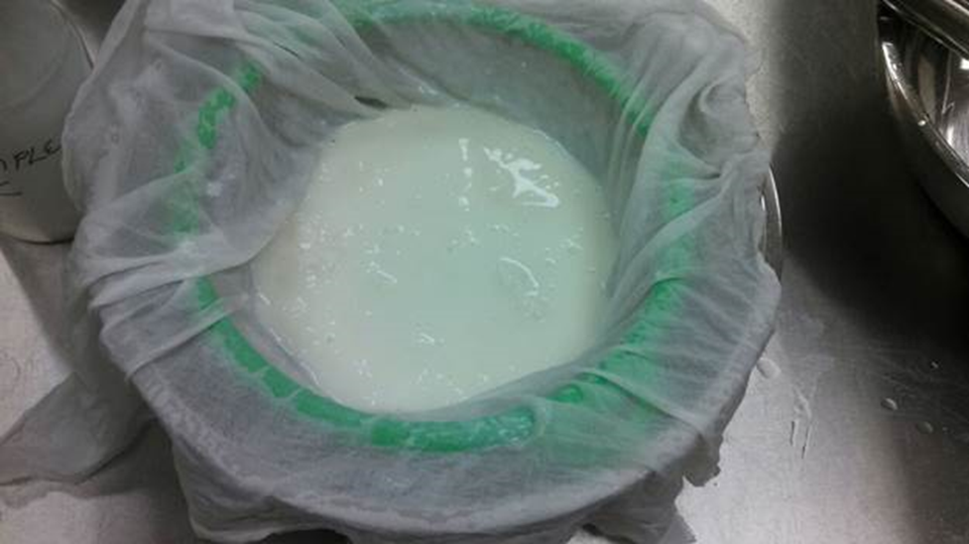
Figure 1 Yoghurt Sample C
DISCUSSION
Sensory Evaluation
A total of ten (10) persons participated in the sensory testing of the yoghurt samples. There were seven (7) males and three (3) females that participated which may lead to gender bias in the results. The data was collected by assigning each response a numerical value from 1-9, with ‘like extremely' assigned the highest and ‘dislike extremely’ the lowest. The mean value and standard deviation were then calculated and recorded. The mean value represents the average score or rating the sample received indicating whether it was liked or disliked overall. Generally mean ratings below 5.0 indicate poor quality foods or foods that are strange to consumers, which can translate into the boundary between acceptable or non-acceptable. Mean ratings 7.5 and higher indicate high quality food or popular foods with consumers such as candy or ice cream. The broad distribution of responses and high standard deviations that occur with foods are typical. This is not due to inaccuracy of the method but reflects the fact that, in people there are wide differences in their feelings about foods. This can surely be indicated by persons that do not consume or like yoghurt at all.
After conducting tests for appearance Sample A received the highest commendation with a mean score of 7.7. Both samples B & C received scores of 7.0 or higher which would indicate all three samples of yoghurt have an appearance that is acceptable to consumers. In the tests conducted for taste, Sample A gained the highest score of 7.0 followed by Sample B at 6.8 and Sample C at 5.8. Sample B had 30% response of dislike responses compared to Sample C's 20% dislike responses. These results indicate that Sample A was most acceptable and liked and despite more people disliking Sample B to Sample C from an individual perspective, collectively it was the second most acceptable for taste. In the test for texture, results indicated that Sample B had the highest mean score of 8.1, Sample A, a score of 7.8 and Sample C a score of 6.6. Sample C was the only sample to receive dislike ratings at 20%. Sample B being rated higher also had the lowest standard deviation which indicated how the responses did not differ much. The test for smell indicated that Sample A was the most acceptable with mean score of 6.4 and Sample C the least acceptable with a score of 4.77, however these low scores meant that overall the scent of the yoghurt was not too popular among consumers. Both Sample A and B were within the acceptable boundaries for consumers while Sample C was not acceptable to consumers.
The ranking test results indicated that consumers preferred Sample A above Sample B and C respectively.
Physiochemical Analysis
The milk used to prepare the yoghurt samples had an initial pH of 6.76. After processing we had the resulting pH in the following samples. Sample A presented a pH of 3.84, Sample B a pH of 3.8 and Sample C a pH of 3.76. The low pH levels are attributed to the length of time (24 hours) the yoghurt was allowed to incubate. These pH levels met the requirements of the FDA of a pH of 4.6 or lower. According to the FDA, yoghurt before addition of bulky flavours should contain not less than 3.25% fat and 8.25% milk solids nonfat. This requirement was not achieved from the onset because the milk used met the requirements for fat at 3.78% but not for milk solids nonfat at 7.89%. The final result of the study was able to obtain was the conductivity of the samples. Conductivity (or Electrolytic Conductivity) is defined as the ability of a substance to conduct electrical current. In this case it was influenced by an increase in ion concentration, which is duly reflected by the drop in pH, which would indicate an increase in Hydrogen ions. The initial conductivity of the milk was 6.32. After processing into yoghurt Sample A conductivity was 7.53, Sample B was 7.05 and Sample C was 7.29.
Further results were not available due to the invalid readings. This can be attributed to two reasons. The readings were below the limits the machine could have processed and read. See table below.
Parameter | Measuring range | Accuracy
Fat | 0,01– 25% | ±0,1%
Solids-non-fat (SNF) | 3% – 15% | ±0,15%
Density | 1015 – 1160 kg/m³ | ±0,3kg/m³
Protein | 2% – 7% | ±0,15%
Lactose | 0,01% – 6% | ±0,2%
Added water | 0% – 70% | ±3
Milk sample temperature | 1°C – 40 °C | ±1%
Freezing point | –0,4°C — –0,7°C | ±0,001%
Salts | 0,4% – 1.5% | ±0,05%

This would seem highly unlikely because of the results received for the milk and the results it produced for the yoghurt analysis. The bacteria cultures would not have reduced the levels of proteins, fats and solids to that extent below those limits and in some cases it may have even increased some of those parameters above.
Another reason is that the machine’s method of analysis may not be suitable for analyzing yoghurt is that it uses ultrasonic technology to analyze samples. The change in chemical structures of compounds such as proteins and fats due to bacterial action and temperature may not have allowed the machine to recognize its structures. This is proven by the fact that the casein family contains phosphorus and will coagulate or precipitate at pH 4.6. Another factor is whey faction of proteins consists of approximately 50% ß-lactoglobulin, 20% α-lactalbumin, blood serum albumin, immunoglobulins, lactoferrin, transferrin, and many minor proteins and enzymes. During yoghurt production these are denatured which gives the advantage of increasing the amount of water that the proteins can bind, which improves the texture of yogurt. These structural changes are not present in fresh, raw, pasteurized or reconstituted milk and therefore the machine’s capabilities were not built for analyzing the specific structures within yoghurt. The final reason is with the ultrasonic technology, the redistribution of particles within the yoghurt, would have ‘confused’ the machine making it impossible to differentiate between the different chemical particles of protein and fat etc.

